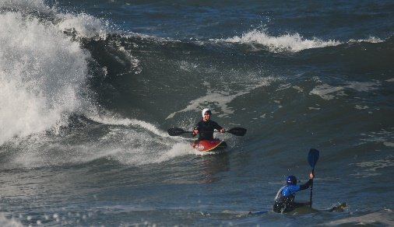
Surf Trip Reminder Notes
This is a useful document to remind leaders and coaches of things to consider when organising and running a surf trip. Please note this document has been produced to help and train leaders and coaches and to assist them when running a surf trip. This is not a set of rules or regulations.
Planning a trip (things to consider):
Ages of Participants – Accommodation – Weather & Environment – Boats and Equipment – How to Get There – Lunch – Contingency - Ability of the Group and Leader – ratio of experience.
Equipment List (depending on weather, environment & trip):
Hot / cold drinks, under clothing (thin or thermal layers, not cotton), suitable spray deck, dry cag / cag, wetsuit, suitable helmet, correct paddles, correct boat, suitable buoyancy aid / impact vest, wet suit boots, dry bag, whistle, gloves, knife with extra-long throw line, first-aid kit, money, phone, shelter.
Clean Rope & Safe Equipment Principles:
Clothing fits correctly, spray decks straps, inside of boat cannot cause entrapment, throw lines are free of loops or knots.
Outfitting of boats surf (to check):
Foot rest / blocks, seat positioned for equal balance, hip pads, back rest, thigh grips and back rest positioned and adjusted for effective body connection with kayak, but also so as not to hinder exiting, correctly fitted and inflated air bags. Swim tails attached at bow and stern grab handles. Internal and external of kayak free of possible snags, all outfitting well secured, condition and suitability of boat. If using surf specific boat, suitable fins which are securely fixed.
Water sports health issues to consider:
Hypothermia, surfers ear, eye damage due to reflected light and paddling through surf, weaver fish, skin cancer, lower back damage due to posture; who has first-aid and rescue knowledge.
Sea:
Tides: times and neap or spring? Different waves/currents at different points in the tide; risks from rips, rocks, beach dump; other water users (board surfers, kitesurfers, swimmers, fishers); areas where to surf, lifeguard flags. Where to paddle out / use of rip.
Pre-paddle briefing:
Count the paddlers and know names, health of participants; sea conditions / waves, wind direction & strength; sandbanks, reef currents and what to expect; surfing zone / paddle out, surf etiquette, priority to paddler at the shoulder, getting out past the break (out the back);
responsibility of leaders and paddlers; communication signals from the beach; orientation towards the beach when out the back and any limits to paddle zone; what way to lean your body when on a wave, who has and where is the safety kit, what to do if you swim, what to do if there is an incident, keep in sight and together; recovery/rescue, group control, lifeguards.
Safety kit bag, kept on beach or by cars:
Large dry bag, marked “SURF SAFETY KIT PLEASE DO NOT REMOVE” place most of the following items inside: spare clothes, drinks, first aid kit, shelter, sun cream, money (coins), sling, spare air bag, bungs, woolly hat, long tow line, long throw line, floatation device.

Walking, lifting, carrying correctly:
Over slippery/sharp rocks, through rock pools, down dangerous paths always make sure your body is next to the bank (boat carried on cliff-drop side).
Leadership:
Group management, KISS (Keep It Short and Simple), line of sight, avoidance is better than cure, position of maximum usefulness, don’t Panic, manage if possible, ensure people know their roles.
Rescue Priority:
Self - Team - Victim – Equipment.
How: Shout – Reach –Rescue; possibly long line from beach; raise alarm with lifeguard.

Rescues
- Self-rescue (Swim or use boat as floatation device)
- Rope or floatation rescue
- X and H rescues
- Unconscious swimmer, injured/marooned paddler
- Back deck rescue
- Out to sea using front deck rescue
- Retrieval of equipment

